**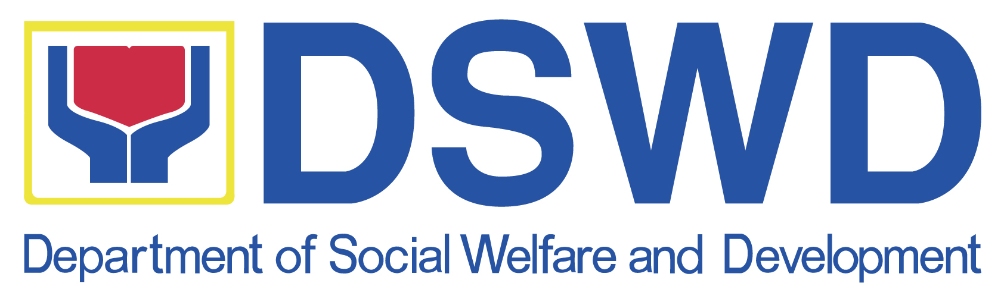*SUSTAINABLE LIVELIHOOD PROGRAM***

*Regional Program Management Office*

*Field Office XII*

**PROCESS FLOW FOR SKA CASE MANAGEMENT**

**(A.O 48)**

|  |  |  |  |  |
| --- | --- | --- | --- | --- |
| **Procedure** | **Activities** | **Tool to be use** | **Responsible person** | **Result** |
| 1.Case load Inventory | Data Analysis | Status of SKA form from NPMO | FPDO | Accurate data on Active and inactive SKA’s |
| 2.Organizational Development Checklist(ODC) | SKA meeting | Standard form ODC | FPDO | Determine the status of organization either for mainstreaming, rehabilitation and delisting |
| 3.Performance Assessment Indicator (PAI) except for 2010 below case | SKA meeting | Standard form PAI | FPDO | Determine the performance of organization either for mainstreaming, rehabilitation only. |
| 4.Progress Notes of the worker | SKA meeting | Progress note template | FPDO,MSWDO | Recommendation for final decision |
| 5.Coppies of Individual passbook, Journal, other financial records(except for 2010 below case) | SKA meeting | Standard FMS form | FPDO, SKA President/Treasurer | Accurate balance of individual and SKA. |
| 6. Case Conference result (Resolution type) | Case Conference Barangay or Municipal level | Template issued by NPMO series of April 2016 | SKA President, Treasurer,FPDO,MSWDO, PC and RPC | Resolution signed by the SKA President, Treasurer,FPDO,MSWDO, PC and RPC |

Prepared by: Approved by:

**IBRAHIM S. SANGCUPAN NORAIDAH T. BUSRAN**

CDED Officer Regional Program Coordinator

06/07/2016